*********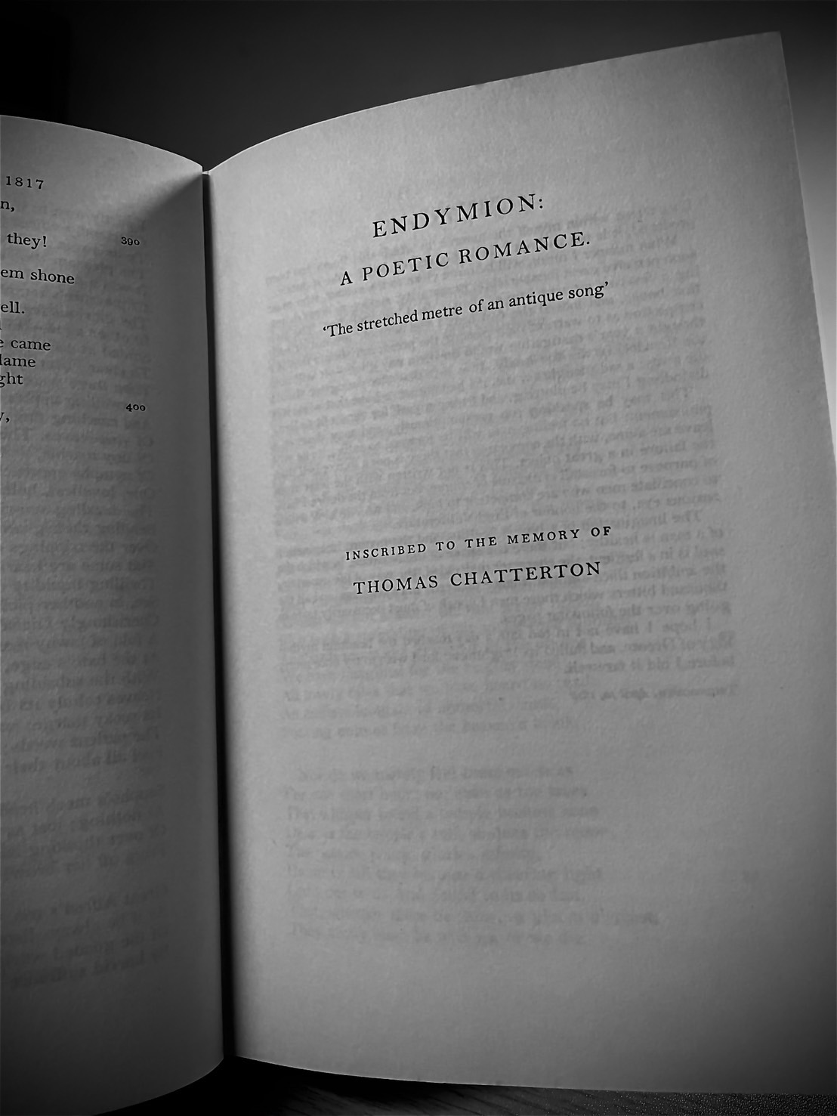***

***The Keats Conference 2026***

***Call for Papers***

**The Annual John Keats Conference**

**June 2026**

***The Keats Circle***

**Keats House, Hampstead, London**

**Friday 5 June - Sunday 7 June 2026**

The Keats Foundation is delighted to announce that the annual John Keats Conference will run from Friday 5 June to Sunday 7 June 2026 at Keats House in Hampstead, London. Our conference theme will be ‘The Keats Circle’.

**Our keynote lectures will be delivered by:**

**Lauren Cooper** (Syracuse University)

**Kate Singer** (Mount Holyoke College)

**Sarah Wootton** (Durham University)

Proposals for 20-minute papers for presentation at the 2026 John Keats Conference are now invited. Our conference theme, **The Keats Circle**, has been broadly conceived to ensure that papers reflectingthe full range of current Keats studies can be accommodated. Please email a paper proposal of 200-250 words, with a title and outline of your proposed presentation, to keatsconfsecretary@gmail.com to arrive by **Saturday 21 February 12 noon UK time**. For obvious reasons, all papers should have a significant Keats dimension.

**Registration will open on Monday 2 March.**

**Acknowledgements**

The organisers offer grateful thanks to the British Association for Romantic Studies, the Keats-Shelley Association of America, the North American Society for the Study of Romanticism, and to Rob Shakespeare and the team at Keats House Museum.

**About Keats House**

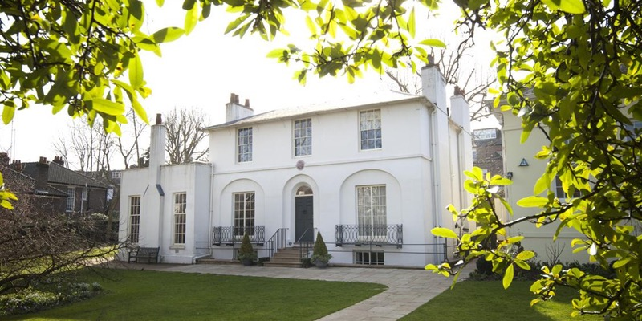

Keats House Hampstead was the home of John Keats from December 1818 until he left for Rome in August 1820. Built circa 1815 and originally named Wentworth Place, the house reflected the gradual suburbanization of Hampstead village then taking place. Divided into two, like a modern semi-detached villa, it was home to Charles Wentworth Dilke and his family and, in the other half, Charles Armitage Brown. Brown had first met Keats in summer of 1817 and the two had become close friends; after the death of Tom Keats, 1 December 1818, Brown invited Keats to share his home as a lodger. It was at Wentworth Place that Keats composed his mysterious and magical lyric ‘La Belle Dame sans Merci’, finished his wonderful narrative poem The Eve of St Agnes, and wrote his great odes of spring 1819 including ‘Ode to a Nightingale’.

While our Conference takes place in the Nightingale Room, attendees are highly encouraged to visit the adjacent Keats House Museum, where they will receive free admission for the duration of the Conference.

Nearest Stations

* **Belsize Park** (Northern Line, 10-12 minute walk)
* **Hampstead** (Northern Line, 10-12 minute walk)
* **Hampstead Heath** (Overground, 3 minute walk)

Although the walk from Hampstead takes in the local high street, it is a steep return journey – when travelling back into central London we recommend using Belsize Park.

Several local buses also stop at South End Green/The Royal Free Hospital, a 5 minute walk away. The Northern Line provides connections for several major stations: St Pancras International, King’s Cross, Euston, Waterloo, and London Bridge. Paddington (for Heathrow) and Victoria (for Gatwick) can be reached by changing at King’s Cross or Euston. There is no parking available at Keats House and attendees are advised to use public transport.

**Registration**

Please bear in mind that if your paper is accepted for presentation you should plan to attend for all or most of the conference programme. Registration covers administrative overheads, teas, coffees, wine reception, Conference Dinner, and so on, for the duration of the conference.

To undergraduate and postgraduate students and unwaged we offer a concession fee. Except for the Conference Dinner on Saturday 6 June, meals during the conference are not covered by the conference fee. Overnight accommodation during the conference is wholly at the discretion of participants, but we have recommendations for accommodation on our website and in the following pages.

Registration fees are as follows for the 2026 conference:

**The regular fee for institutionally affiliated staff is £200 per person**, which includes the administrative charges for letters of attendance and signed receipts for reimbursements.

**Concessionary rates for undergraduate and postgraduate students, as well as unwaged participants will be £100.**

These fees include the dinner on Saturday 6 June. Day rates will be available, and these will not include the Conference dinner. Details about day rates will be made available after registration opens.

If you have significant funding deadlines please alert us to these.

Further donations will be accepted with gratitude at:

https://keatsfoundation.com/support/

Donations will **not** affect consideration or acceptance of paper proposals; the decision of the conference organisers will be final. Details on how to pay the conference registration fee will be made available when registration opens at **12 noon on Monday 2 March 2026**.

**Accommodation**

Conference delegates are welcome to book their own accommodation. These accommodation opportunities are conveniently located to the venue:

* **Premier Inn Hampstead Heath** is a 10-minute walk from Keats House and Hampstead Heath Rail Station.
* **Best Western Swiss Cottage Hotel** is less than 30 minutes walk away from Keats House and is also accessible by overground train between Finchley Road & Frognal and Hampstead Heath stations.
* **University College London Accommodation** offers affordable rooms for individuals and groups in Central London halls of residence.

More information about accommodation is available on: <https://keatsfoundation.com/event/keats-conference-2025/>

**Drinking & Dining**

All delegates are welcome to the drinks reception on Friday afternoon. The full Conference attendance rate includes dinner at The Garden Gate Pub on Saturday, and must be pre-booked. At all other times, delegates are free to explore Hampstead’s eateries, such as:

* **The Nook** (cafe)
* **Silverberry** (Mediterranean)
* **Franco Manca** (pizza)
* **Paradise** (Indian)
* **The Freemasons Arms** (gastropub)
* **The Roebuck** (gastropub)

Please check email correspondence from us for updates and do get in touch if you have any questions.