Call for Papers

The Annual John Keats Conference
May 2024

John Keats in 2024: Prospects and Retrospections

Presented by Keats Foundation, and hosted at Keats House Hampstead

A Three-Day Keats Foundation Conference at Keats House, Hampstead, London

Friday 17 May - Sunday 19 May 2024

Keynote Speakers:
Andrew Bennett
Ella Kilgallon
Jonathan Mulrooney

We invite proposals for 20-minute papers for presentation at the 2024 John Keats Conference. Our conference theme, John Keats in 2024: Prospects and Retrospections, has been broadly conceived to ensure that papers reflecting the full range of current Keats studies can be accommodated. Please email a paper proposal of 200-250 words, with a title and outline of your proposed presentation, to keatsconference2022@gmail.com to arrive by Saturday 17 February 12 noon UK time. For obvious reasons, all papers should have a significant Keats dimension.

Registration will open on Friday 1 March.

To find out more about Keats Foundation, go to:

https://keatsfoundation.com/

For Keats House, please visit:

https://www.cityoflondon.gov.uk/things-to-do/attractions-museums-entertainment/keats-house

Please bear in mind that if your paper is accepted for presentation you should plan to attend for all or most of the conference programme. Registration covers administrative overheads, teas, coffees, wine reception, Conference Dinner, and so on, for the duration of the conference.

To undergraduate and postgraduate students and unwaged we offer a concession fee. Except for the Conference Dinner on Saturday 18 May, meals during the conference are not covered by the conference fee. Overnight accommodation during the conference is wholly at the discretion of participants.

If you have significant funding deadlines please alert us to these.

Registration

Registration fees are as follows for the 2024 conference:

The regular fee for institutionally affiliated staff is £200 per person, which includes the administrative charges for letters of attendance and signed receipts for reimbursements.

Concessionary rates for undergraduate and postgraduate students, as well as unwaged participants will be £100.

These fees include the Conference dinner on Saturday 18 May.

Day rates will be available, and these will not include the Conference dinner. Details about day rates will be made available after registration opens.

Further donations will be accepted with gratitude at:

https://keatsfoundation.com/support/

Donations will not affect consideration or acceptance of paper proposals; the decision of the conference organisers will be final. Details on how to pay the conference registration fee will be made available when registration opens at 12 noon on Friday 1 March 2024.

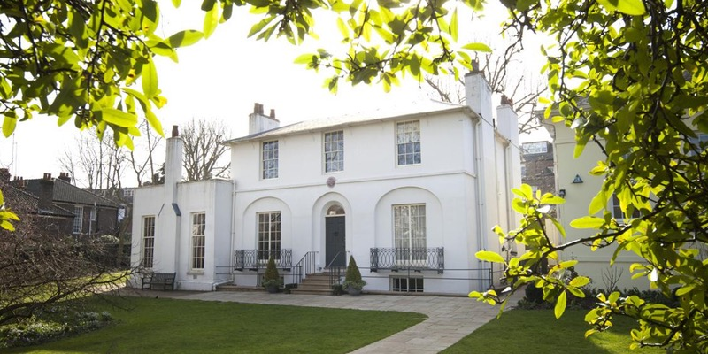

The Keats Foundation is a Registered Charity in the UK (No. 1147589).

