October 31, 2022:

227 years ago today, October 31, 1795, John Keats was born! To celebrate, Harvard University Press is publishing the much anticipated …

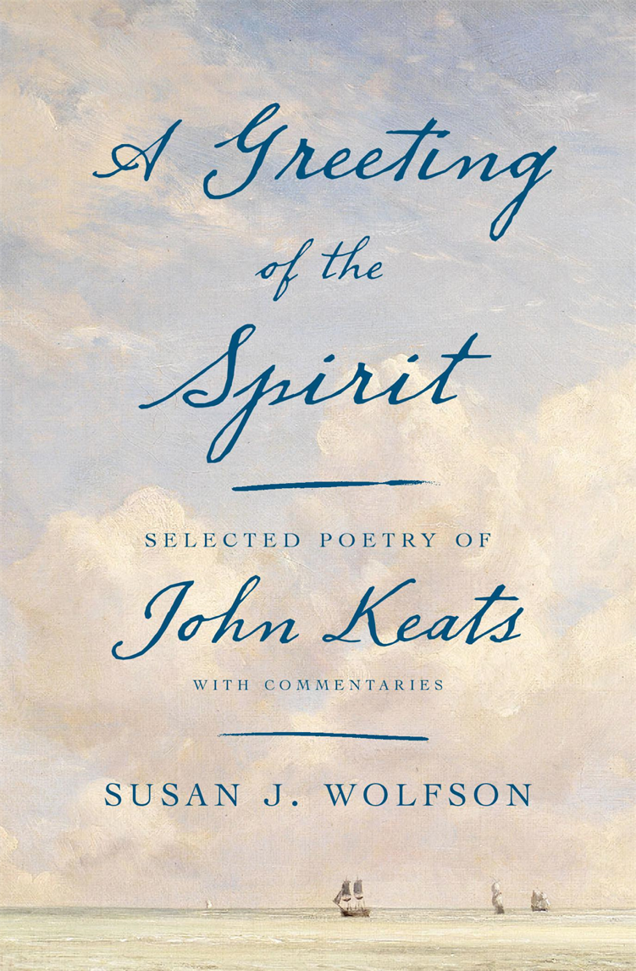

The gorgeous cover, a detail from John Constable’s Harwich Lighthouse, alludes visually to the source of the book’s title, a comment Keats made to a friend about the life of imagination: “Things semireal such as Love, the Clouds &c which require a greeting of the Spirit to make them wholly exist—" (13 March 1818). Keats regarded poetry as a living event, a cooperative experience shared between author and reader. This is the temper of Susan Wolfson’s engagement. With seventy-eight selections from his work, each accompanied by a commentary on its form, style, meanings, and relevant contexts, greeted readers will rediscover a virtuoso poet, by turns lively, experimental, self-ironizing, outrageous, and philosophical. Included are such favorites as the Great Odes, La Belle Dame sans Merci, and The Eve of St. Agnes, as well as less familiar poems, several in letters to family and friends never meant for publication. A Greeting meets the breadth and depth of Keats’s poetic imagination, from intellectual jests and satires to erotic bandying, passionate confessions, and reflections on mortality, while conveying a chronicle of Keats’s artistic and personal evolution. The commentaries, at once critically attentive and conversational, illuminate the lively complexities of Keats’s verbal arts and stylistic experiments, his earnest goals and nervous apprehensions, and the pressures of politics and literary criticism in his day.

$35.00 / ISBN 9780674980891 / 480 pages / 16 photos More information here
https://www.hup.harvard.edu/catalog.php?isbn=9780674980891&content=reviews

