Preliminary Announcement

Seventh Bicentennial John Keats Conference

John Keats in 1820

A Three-Day Keats Foundation Conference at Keats House, Hampstead, London

Friday 15 - Sunday 17 May 2020

Keynote Speakers

John Barnard

Richard Lansdown

Sarah Wootton

The Keats Foundation is delighted to announce its seventh bicentenary conference, 'John Keats in 1820', which will be held at Keats House, Hampstead 15-17 May 2020.

1820 was the year that saw the publication of Keats’s third collection — Lamia, Isabella, The Eve of St. Agnes and Other Poems. A little over two months after the book appeared, Keats boarded the Maria Crowther at Tower Wharf, and sailed for Italy where he aimed to pass the winter.

In due course we will be inviting proposals for 20-minute papers for presentation at the 2020 John Keats Conference. Possible themes, which are not exclusive, might include:

Keats’s 1820 collection and the poems in it. Unpublished Keats in 1820. New poems. The 1820 letters. The Keats Circle in 1820. Keats and melancholy. Keats and tuberculosis. Friendships. Journeys. Financial entanglements. Keats and copyright.

For obvious reasons, all papers should have a significant Keats dimension.

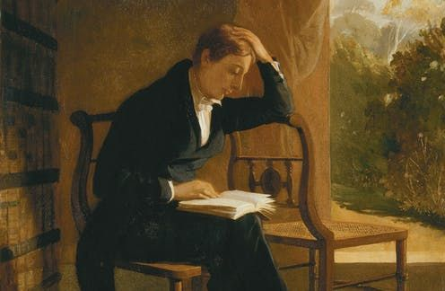

Lectures and papers will be presented in the spacious Nightingale Room adjacent to Keats House. We will explore the Keatsian locality, Hampstead Heath, and Leigh Hunt’s Vale of Health. For conference announcements and further information about the Keats Foundation please go to

https://keatsfoundation.com/

For Keats House, please visit

https://www.cityoflondon.gov.uk/things-to-do/keats-house/Pages/default.aspx

